DPP-4

**Name : Adya verma**

**Class : Mba 1st year**

1. Calculate the total number of companies in the dataset.

Query : SELECT count(name) FROM TrendsInStartups_Explorin

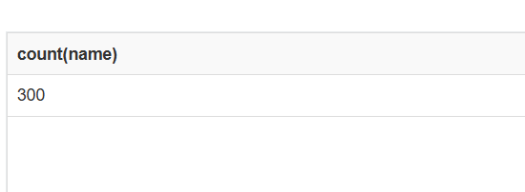

1. Determine the total value of all companies in the dataset

Query : SELECT sum(valuation) FROM TrendsInStartups_Explorin

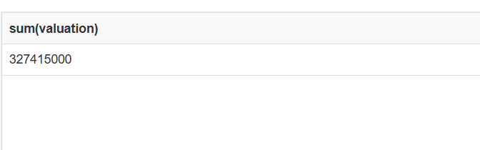

3. Find the highest amount raised by a startup at the 'Seed' stage.

Query : SELECT Max(amount_raised) FROM TrendsInStartups_Explorin where stage = "Seed"

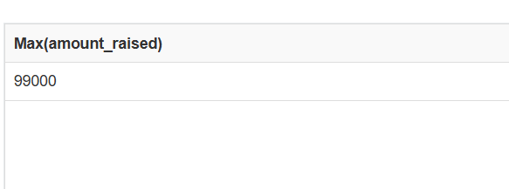

1. Identify the year when the oldest company on the list was founded.

Query : SELECT min(founded_year) FROM TrendsInStartups_Explorin

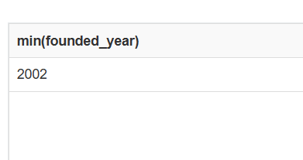

5. Calculate the average valuation within each startup category.

Query : SELECT distinct(sector) , avg(valuation) FROM TrendsInStartups_Explorin group by sector

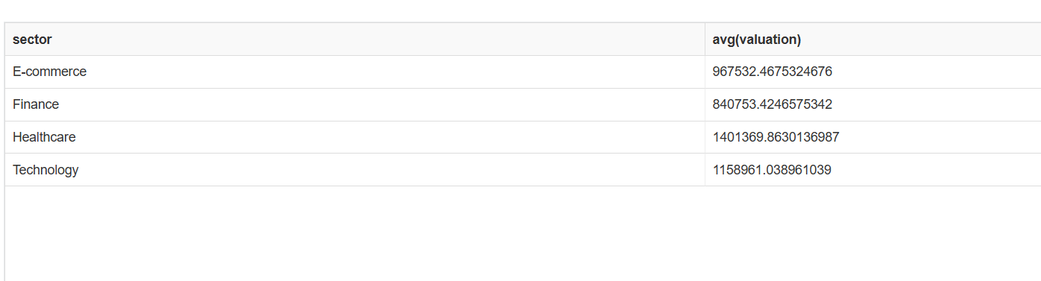

6. Determine the top locations with the highest number of startups.

Query : SELECT distinct(location) , max(size) FROM TrendsInStartups_Explorin group by location;

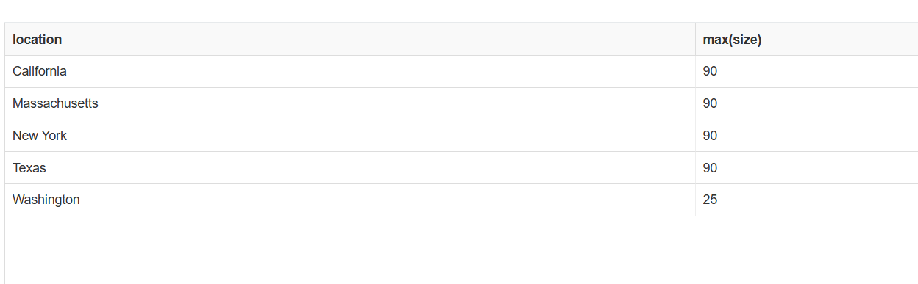

7. Calculate the average size of startups in each location where the average size

exceeds 500.

Query : SELECT distinct(location) , avg (size ) FROM TrendsInStartups_Explorin group by location having avg(size)>500



8. Find the top 5% of startups with the highest valuations

Query: SELECT distinct(name) , sum(valuation) as Valued from TrendsInStartups_Explorin group by name order by Valued desc limit 15

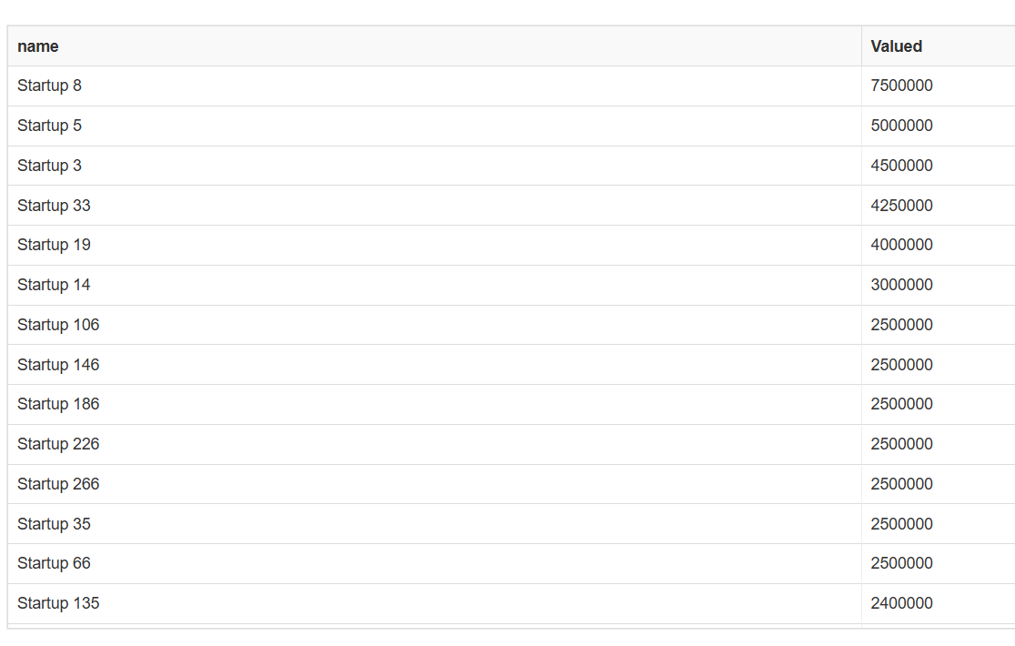

9. Identify startups that have raised funding in every stage (Seed, Series A,Series

B, etc.).

Query: SELECT name , count(stage) as A FROM TrendsInStartups_Explorin group by name having A=4;



10.Calculate the percentage growth in valuation from Seed stage to Series A for

each startup.

Query : SELECT

s.name AS StartupName,

s.valuation AS SeedValuation,

a.valuation AS SeriesAValuation,

((a.valuation - s.valuation) * 100 / s.valuation) AS PercentageGrowth

FROM

(SELECT name, valuation FROM TrendsInStartups_Explorin WHERE stage = 'Seed') s

JOIN

(SELECT name, valuation FROM TrendsInStartups_Explorin WHERE stage = 'Series A') a

ON s.name = a.name;

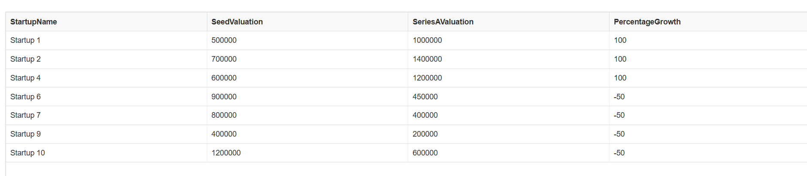

SELECT name , count(stage) as A FROM "TrendsInStartups_Explorin" group by name having A=4;